**06. CodeBuild Introduction**

--- Reference - <https://github.com/stacksimplify/aws-eks-kubernetes-masterclass/tree/master/11-DevOps-with-AWS-Developer-Tools>

--- in this lecture, we are going to understand codebuild on very high level. What is this codebuild Service and then how we are going to use it.

**Codebuild interdiction**

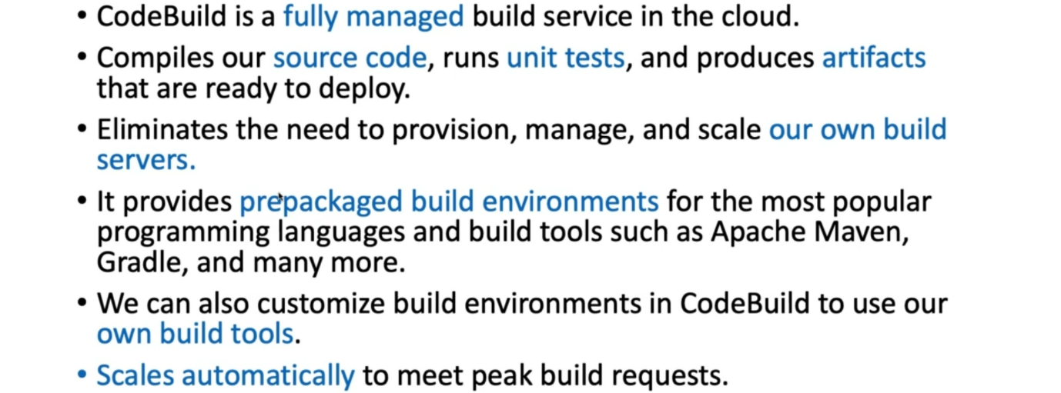

**How to run builds**

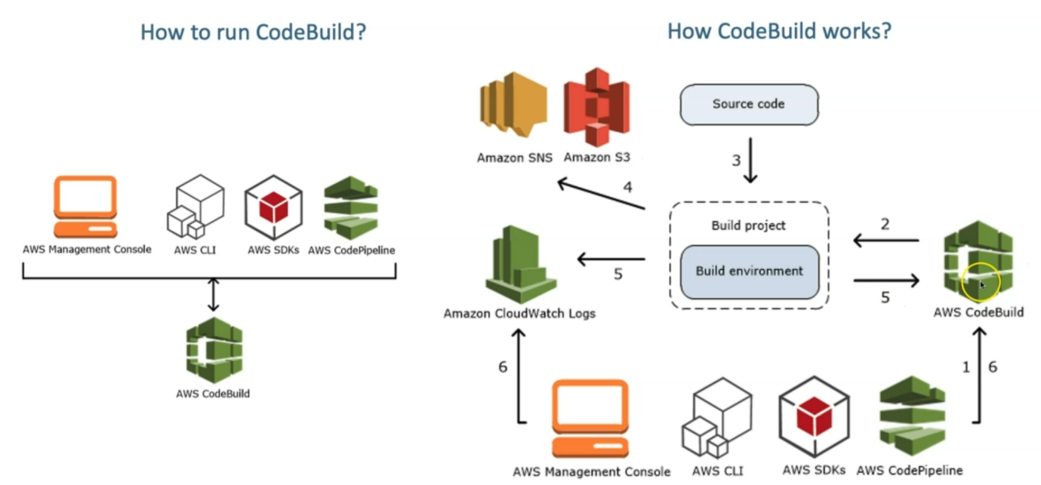

--- So, if you want to run codebuild manually, you can run it from management console. You can run it from AWSCLI or from AWS SDK or AWS codepipeline.

--- in our case we are going to run codebuild using codepipeline. that's what we are going to do.

--- how code build works, let's see how. So, if you are using the code pipeline, what happens on the overall story? We are going to see now.

--- as a developer, we are going to checking the code to your respective source code repository. So, what happens is like once the change is triggered inside the source code, the code pipeline will

know that and then it will trigger that pipeline operation. So, immediately codebuild will trigger and take the latest source code version from our source code codecommit repository or get GitHub repository or whatever is configured as source code repository.

--- from there, it will start the build process.

--- during the build process. If the build is failed, if you want to send the notifications. So, it can send a notification using Amazon notification service (**Simple notification service**).

--- it also logs all the build the logs inside of the cloud watch during that process. in addition to that, it will have built environment, which is a purely a docker container environment, or we can build our own docker image and then use that as our built environment, whatever we need.

--- **note** - so we have options to use managed Dockery images for built environment or custom-built Dockery images for built environment.

--- So once that build is completed. it is going to store the artifacts inside the S3 buckets. We are going to trigger build using codepipeline.

**Codebuild architecture**

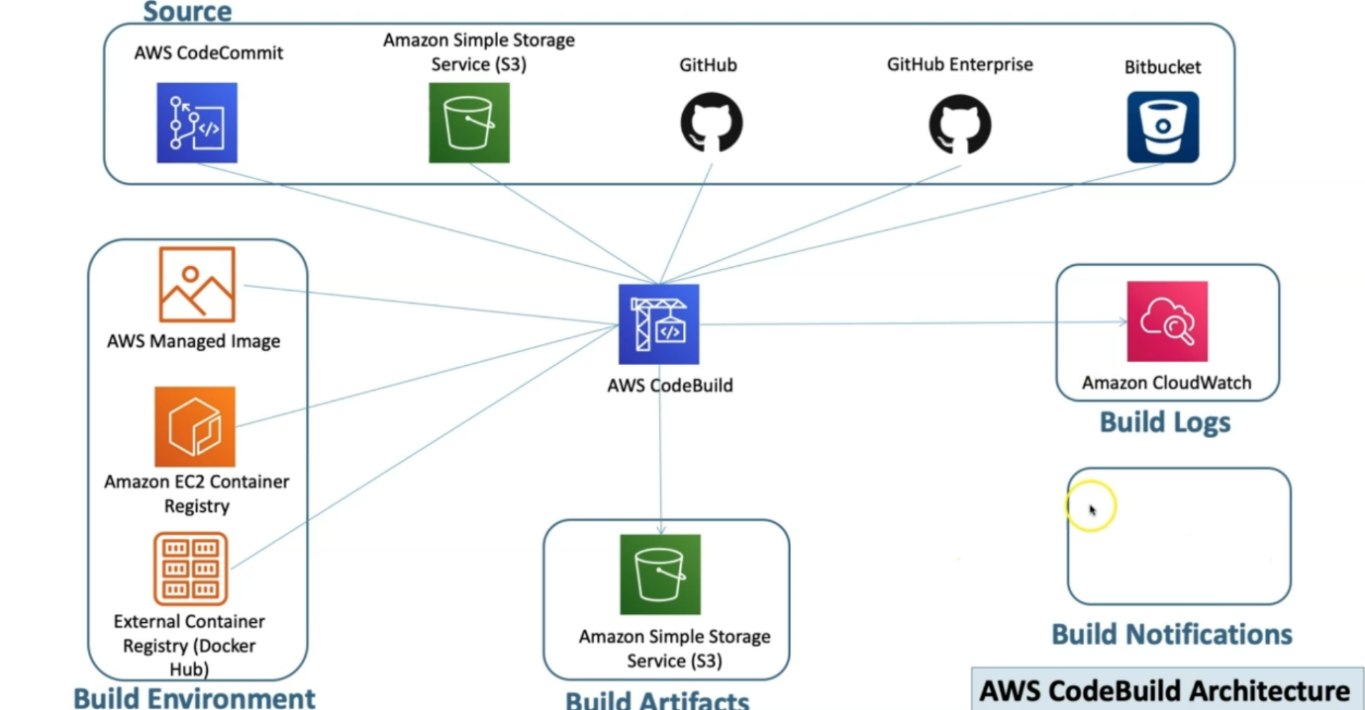

--- So, the code build architecture we are going to see on a very high level.

--- this is the build environment, so which will have the managed images and then our custom emerges, we can push to EC2 container registry our images can be present in dockerhub. those images we can use to use as a build environment inside the aw codebuild.

--- **note** - it is a very, very good feature.

--- So, if we have already existing built process in our organizations and then if we want to integrate with code build, then get that respective container or your manual build process converted into your own container and then bring it here and then start using it under codebuild. this is the built environment.

--- The next thing is the source. So, codebuild codecommit service. in addition to that, it also supports simple storage service which is S3 and also supports GitHub, GitHub Enterprise and even also the BitBucket.

--- once the build is completed, it is going to store it in the s3 buckets. In addition to that build, the logs are stored in cloud Watch and build Notifications are sent to using simple notification service.

**Code build steps**

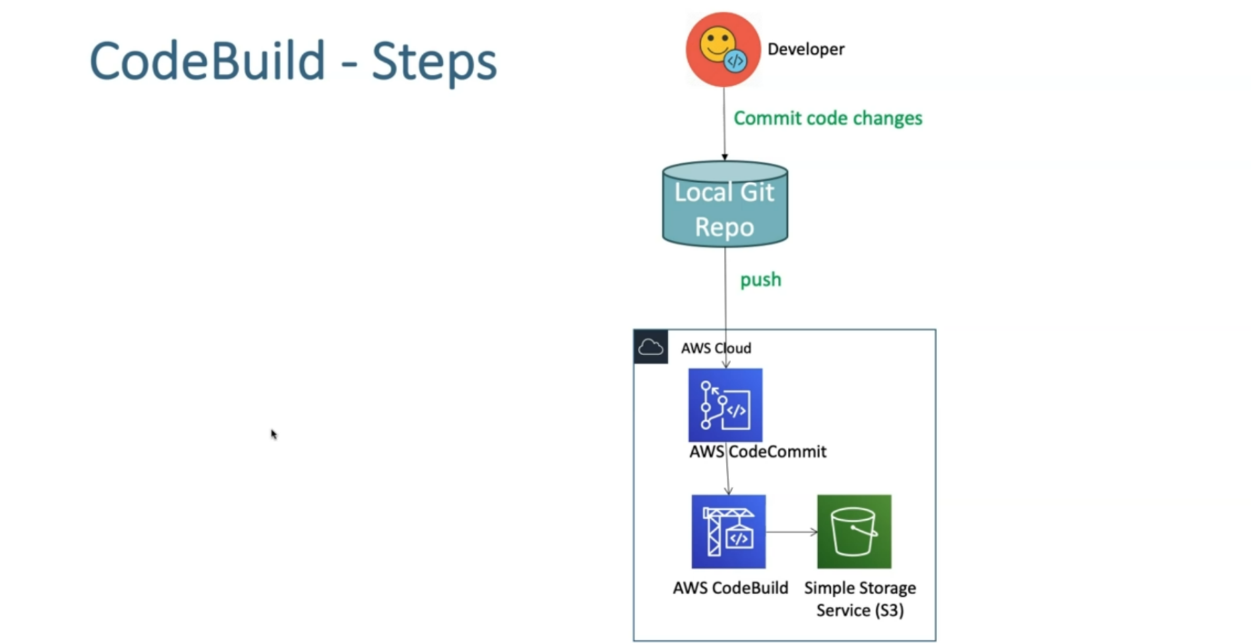

--- as a developer, I check in the code to local git repo and the push the same code to aws codecommit and from the codebuild if you want to run the build manually then you can reference that respect to code commit version then run your build and then it automatically stores the artifacts in that simple storage service, which is S3.